Corpus Christi Catholic Primary School
Year 1 Curriculum Overview Summer 2 2026

This half term, our Curriculum Enquiry Question is……
What is wonderful about our world?

Our School Gospel Virtue is Compassion
RE |  | Catholic Character Education/RSHE |  | English
We will continue our learning of Pentecost and Mission and explore the meaning of the Holy Spirit. We will learn about the events that occurred during Pentecost and reflect on the symbols. We will then explore other faiths and learn about Islam. We will then start our topic of sacraments where we will explore when God is close to us and how forgiveness can be healing. |  | CCE:  We will continue learning about Compassion, what compassion means and how we can show compassion to others as well as ourselves.  RSHE: This half term, we will be learning about money. We will look at different forms of payment, how we earn money and ways to save. We will also start transition into Year 2. |  | 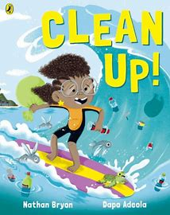  We will start the half term using our class book - Paddington by Michael Bond - as inspiration for our writing and we will write some instructions on how to make Paddington’s favourite food - a marmalade sandwich!  We will then be writing a Poem, using inspiration from our model text ‘Clean Up!’ by Nathan Bryon. We will be writing an acrostic poem based on the environment.
Maths |  | History/Geography |  | Arts and Culture
This half term we start with the topic, Place value within 100, learning to recall numbers, count to 100 and partition into tens and ones. We will explore money and learn to add, subtract and recognise coins. We will finish Year 1 by learning to tell the time at o’clock and half past. |  | This half term, we will be looking at the 7 wonders of the world in geography. We will start off by learning the names of the seven continents and where they are located on a World map. We will learn about the 7 natural and man-made wonders and explore where they are on the world map. |  | Art: In art, we will be exploring patterns. We will also be looking at the artist William Morris.  Music: This half term, we will continue our work in finding the pulse of songs. | Computing: This half term, we will be using beebots to help us develop our programming skills. We will focus on giving clear instructions that the computer can follow.
Science |  | PE |  | Curriculum Texts
This half term, we will be learning about everyday materials. We will learn to describe different materials and explore their different properties. We will also be experimenting with different materials and testing out how waterproof they are. |  | We will start by continuing to practise the skills needed for sports day. These include racing, jumping and throwing.  In outdoor PE, we will be focusing on running. This includes learning the correct form and running games.  In indoor PE, we will focus on jumping. We will explore different techniques of jumping and different types of jumps. |  | 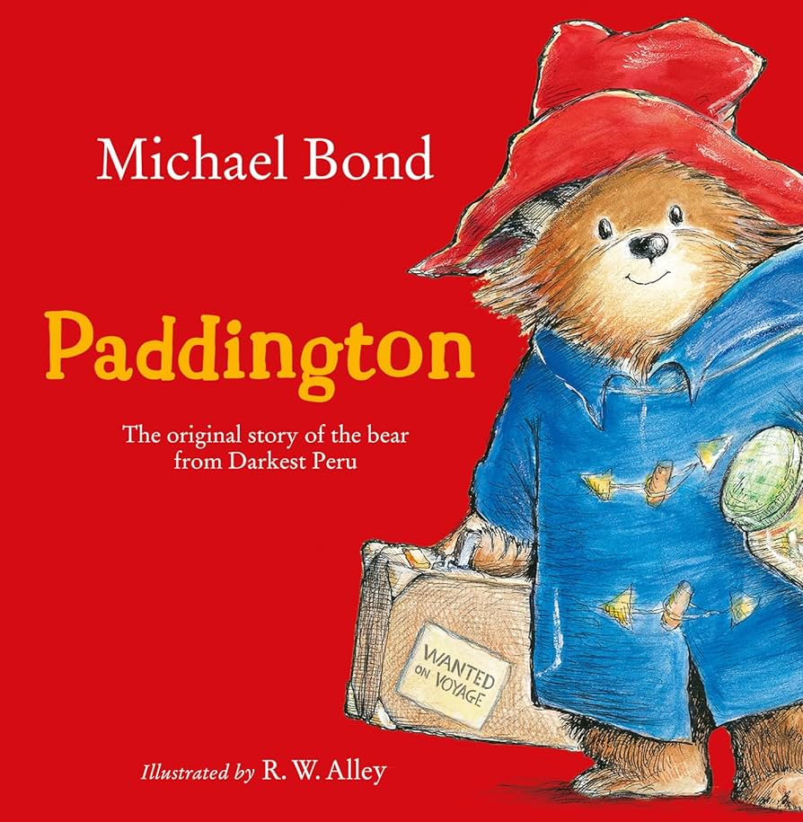
General Information
Important dates:

Phonics screening checks will take place throughout the week beginning Monday 8th June.

Year 1 Sports Day - Friday 19th June

PE days - Monday and Tuesday

Homework - Thursdays, due Tuesdays

Please make sure that with the weather warming up that your child has a named water bottle and hat in school. Please could you also ensure that every item of uniform is clearly labelled with your child’s name to prevent missing items.

