Corpus Christi Catholic Primary School
Year 5 Curriculum Overview Summer Term 2 2026
This half term, our Curriculum Enquiry Question is
Does having more make us happier?

Our School Gospel Virtue is Compassion
RE |  | Catholic Character Education/RSHE |  | English
In our RE curriculum, we will be finishing our learning about the liturgical season of Pentecost. We have consolidated our understanding of the Holy Spirit and how this can guide us to be good citizens in our world today.  Then we will move onto our learning of the Sacraments and how this can encourage us further to have a positive and proactive impact. |  | CCE: This half term we will be focusing on our Gospel Virtue of Compassion. We will look into what it means to have compassion and different ways of showing it to others.  RSHE: We will be consolidating our learning on future aspirations, education and careers, and we will be moving onto understanding how bodies grow and change as we get older.  We will also recap first aid skills, including how to call for help and how to support someone if they are unwell or injured. |  | In English, we will be developing more skills over different genres of writing such as script writing and a balanced argument.  Script writing will help us to further develop our speaking and listening skills as we will be performing plays in front of our classes. We will link this to our history topic on smugglers.  We will end the year with a poetry unit.
Maths |  | History/Geography |  | Arts and Culture
In maths this half term, we will start by finishing our decimals topic. Through this we will recap multiplying and dividing by 10, 100 and 1,000.  Next we will learn about negative numbers. We will be able to count backwards from zero and use a thermometer to see negative numbers in a real life context.  Finally we will end the year by converting different units of measurement and also being introduced to the concept of volume. In both of these topics we will practise our reasoning and problem-solving skills. |  | We will continue our Geography topic on our local coasts. We will recap the different coastal features that can be found near where we live.  Our history topic this half-term is all about smugglers. This will consolidate our recent learning in geography. We will learn what the life of a smuggler entailed, look at famous smuggling routes and understand how smuggling impacted the local area.  We will also learn about notorious smugglers who lived in our local area, including Isaac Gulliver. |  | Art:  The children will be creating their own eco art. Through this they will be learning about lines of symmetry.  Music:  The children will be learning the basic skills of playing the ukulele. | Spanish:  ‘Mi Casa’  Learning how to talk about and describe where we live.  Computing:  We will continue our learning on the Mars Rover. We will finish our pixel art and try to create our own code.  We will then learn about online safety, including the need for strong passwords, how our online reputation affects the real world and the consequences of online bullying and how to prevent it.
Science |  | PE |  | Curriculum Texts
In Science, we will continue to extend our learning on living things by specifically looking at the human life cycle. Focussing on each stage of human life, we will look at pregnancy, infancy, early childhood, adolescence, adulthood and old age. The children will investigate what developments the human body goes through at each stage and what environmental factors can affect this. |  | Outdoor: Sports day preparation  For the next few weeks, the children will be continuing to prepare for sports day. We will be practising all of the events that the children will be doing including athletics.  Outdoor: Pickleball  The children will recap their knowledge of pickleball from last year. We will start by learning the rules of the game and practising skills such as how to accurately hold the racket. We will then move on to playing whole games as a class. |  | 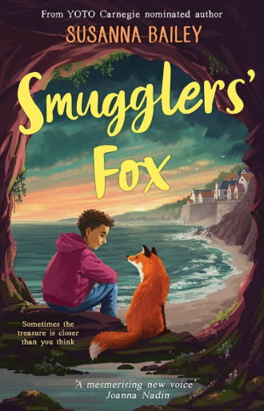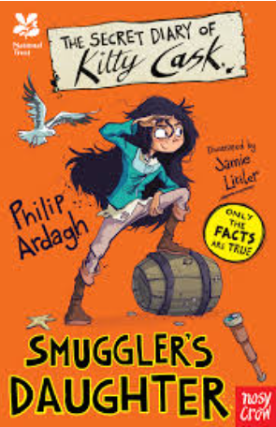
General Information
Important dates: Monday 29th June- KS2 Sports day.
Beach trip- Date to be confirmed and further information to follow.

PE days: Tuesday, Thursday and Friday (5C only).

Homework: Instructions will be posted on Google Classroom on a Thursday and the homework should be completed in their book. It is then due on Tuesdays.

All children can access their times table rockstars accounts at home, this is a helpful resource for the children to develop their fluency.

Reading records are due every Wednesday. The children should have at least four comments in their record.

Water bottle - In school everyday and named.

Please make sure that all items of uniform have names in them and check that names have not washed out.
As we approach the summer months, please ensure the children wear sun cream and have a hat at school.

