Corpus Christi Catholic Primary School
Year 3 Curriculum Overview Summer Term 2 2026

This half term, our Curriculum Enquiry Question is
How do relationships affect us?

Our School Gospel Virtue is Compassion.
RE |  | Catholic Character Education/RSHE |  | English
This term, our RE learning will focus on the Sacraments, with a particular emphasis on the Eucharist. The children will begin by recalling and building upon their existing knowledge of the sacraments and exploring their importance in the life of the Church.  They will learn about the different parts of the Mass and deepen their understanding of what happens during the celebration of the Eucharist. Through the Gospel story of The Feeding of the Five Thousand, the children will explore how Jesus cared for and nourished His followers and consider how He continues to feed and strengthen us today through the Eucharist.  The children will also reflect on the gift of Holy Communion and discuss ways they can show gratitude for Jesus’ presence in the Eucharist through prayer, participation in Mass and living out Christian values in their daily lives. |  | In RSHE we will focus our learning on three key areas:  -What keeps us safe?  -Safety and the Changing Body  -First Aid: Bites and Stings  In our Catholic Character Education lessons, we are looking at the school's gospel virtue of Compassion. The children will revisit the Parable of the Good Samaritan and consider why and how this demonstrates compassion. The children will think about how they can be a compassionate person in their daily lives. |  | We will move onto non-fiction, looking at discussion texts and balanced arguments. The children will understand the features of a balanced argument. At the end of this unit, the children will write a balanced argument based on our class text from last term (Fantastic Mr Fox).  We will then look again at fiction, with a focus on writing speech. The children will understand the features of written speech and use these to write a piece based off of our curriculum text this half term.
Maths |  | Geography |  | Arts and Culture
In maths, the children will be learning how to subtract and add fractions alongside with calculating the fractions of amounts.  Secondly, the children will be learning about time where they will learn how to read analogue and digital clocks to the nearest 5 minutes as well as measuring and comparing the duration of time.  Also, all children will learn to recognise all coins and notes, and with the knowledge of how to write amounts using both pound (£) and pence (p). Also, the children will be learning how to add and subtract amounts of money to find the sum.  All children will also learn how to calculate change by working out how much change should be given when paying for items, typically working with amounts up to £10. |  | This half term in Geography, we are going to be looking at homes.pupils will explore settlements and learn the differences between villages, towns and cities. Using Ordnance Survey maps they will investigate Boscombe High Street, identifying key features, land use and locations using four-figure grid references. Children will observe human features in the local area and collect data on shops and amenities. They will consider what makes a community feel welcoming and how settlements change over time by comparing historical and modern maps of Boscombe. Pupils will also compare homes and ways of life in different parts of the world, including Cairo and Warsaw, and explore the reasons why people choose to migrate and settle in new places. |  | Art and DT:  Both classes to complete weaving. Then we go on to look at architecture, drawing buildings from different perspectives.  Music: In music we will be learning the recorders. | Spanish:  This term we will be learning about ancient Britain, including the Stone Age, the Bronze Age, and the Iron Age. We will explore how people lived during each period and how life changed over time. We will also learn how to say "man" and "woman" in each of these historical ages and how they were represented.
Science |  | PE |  | Curriculum Texts
In Science, this term we are learning about plants. In addition the children will be learning about the functions of a plant, how plants produce their own food, the plant cycle, how a seed is formed into a plant and also the different ways how seeds travel.  The children will also investigate the effects that water, temperature and sunlight has on the growth of a plant. Also, the children will learn about how pollen is transferred between flowers which is vital for plants to make seeds. |  | Indoor: All Year 3 children will be exploring the basic principles of a canon and unison in gymnastics.  Outdoor: Children will practice the long distance run, sprint, howler throw and the standing long jump which are the statutory events of Sports Day ( which is on the 29th June). |  | 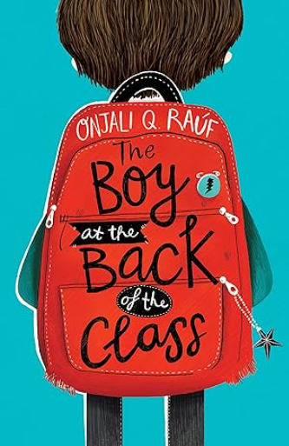
General Information
KS2 Sports Day - King’s Park Athletics Stadium - Monday 29th June

PE days: Wednesday and Thursday

Homework - Set Thursdays and to be handed in on Tuesdays

