Corpus Christi Catholic Primary School
Year 4 Curriculum Overview Summer Term 2 2026
This half term, our Curriculum Enquiry Question is
“Why doesn't everyone have access to healthcare?”

Our School Gospel Virtue is: Compassion
Catholic Social Teaching: Subsidiarity
RE |  | Catholic Character Education/RSHE |  | English
In RE this half term, the children will be reflecting on the different Sacraments. They will look at Sacraments important to them such as Baptism, Reconciliation, Holy Communion and Confirmation and as well as the other remaining Sacraments. We will think about specific scripture that helps to prepare us for this journey and link this to everyday life.  The children will conclude their learning on this unit by answering the Big Question ‘How does our belief in our vocation invite us to bring others to know God’s way?’ |  | In CCE, we will be exploring our school Gospel Virtue of ‘Compassion’.  In CST, we will explore the principle of ‘Subsidiarity’.  In RSHE, the children will be learning about basic first aid, care of ourselves both physically and digitally and how to respond in an emergency situation. This will include asthma, age restrictions, cuts and bruises and more. |  | Fiction - Playscripts  Children will write a theatrical performance, including formatting dialogue and stage directions. They will use character names, colons, and italics to help actors bring the story to life on stage  Non-fiction - Balanced Arguments  They will explore both sides of a topic fairly and look at reasons for and against an issue equally without favoring one side. They will then reach a final conclusion  Poetry - Limericks  Children will produce short, humorous, five-line poems exploring rhythm, syllable counting, and rhyme schemes.
Maths |  | History |  | Arts, Languages and Computing
To begin this half term, children will be learning about shape. They will consolidate shape names and properties taught in earlier years and begin to understand angles as turns as well as identify acute, obtuse, right and straight angles. They will then build on this and compare and order angles. We will then look in more detail at naming and describing different types of triangles, quadrilaterals and polygons. Finally, we will learn about symmetry and how to create a symmetric figure.  To end the year, we will learn about position and direction. This will include describing positions using coordinates and plotting our own coordinates, drawing 2-D shapes on a grid and translate on a grid as well as describe translation on a grid. |  | This half term, the children will be exploring the history of medicine. They will begin by looking at the foundations of early medical practice, including the Ancient Egyptians and Hippocrates, often known as the Father of Medicine. From there, they will move on to key pioneers such as Louis Pasteur and Alexander Fleming, before finishing with modern breakthroughs like DNA and the development of the Covid vaccine.  To bring the topic to life, the children will also take part in an investigation, carrying out a class experiment to observe how bacteria grows. |  | Art: Van Gogh Sunflowers:  Music: Exploring Rounds: | Spanish: La clase:  The children will be learning common classroom items and revisiting possessive adjectives.  Computing: Online Safety:  This half term, children will consolidate their knowledge of online safety and prepare themselves to be adequately equipped to deal with concerns they may face in the digital world.
Science |  | PE |  | Curriculum Text
Year 4 will conclude the year with an exciting unit on electricity. The children will be building a variety of electrical circuits, with a particular focus on different types of switches and how they function within a circuit. They will also explore alternative ways of constructing circuits and investigate which materials make the most effective wires.  Drawing on their understanding of conductors and insulators, the children will then apply this knowledge to design and create their own switches, experimenting with a range of mechanisms and materials. |  | Indoor: Gymnastics  Year 4 will be practising their gymnastic skills with a particular focus on levels and direction.  4D will continue swimming this half term fro four more lessons. Please check for communication regarding specific dates.  Outdoor: Sports Day Practice:  For their outdoor PE lesson, we will introduce the children to the activities they will compete in during sports day. This will include running, throwing and jumping events. |  | 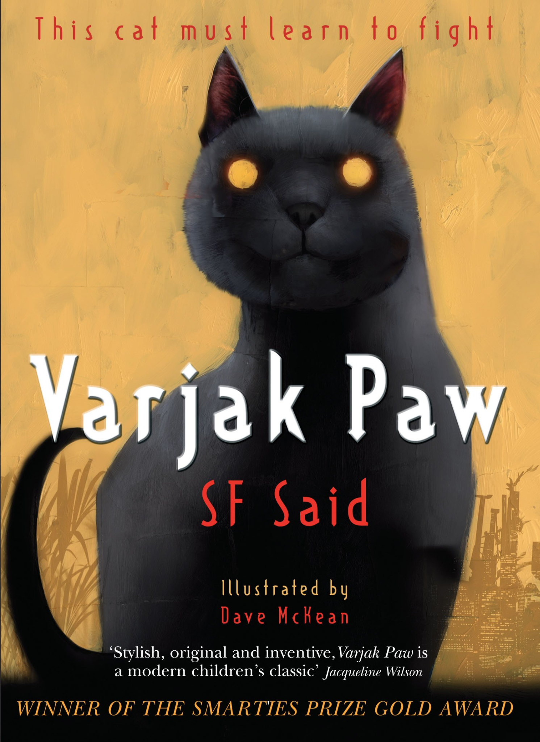
General Information
Reminders and Dates:
PE days: Tuesday and Fridays - Please send your child to school in their PE kit on these days.
Homework: Instructions will be posted on Google Classroom on a Thursday and the homework should be completed in their book. It is then due on Tuesdays.
Times Table Rockstars should also be used daily to support the learning of times tables.

Reading records are due every Tuesday. The children must have at least four comments in their record.

Water bottle - In school everyday and named.
Please make sure that all items of uniform have names in them and check that names have not washed out.

Dates:
- 4D swimming this half term - please check communication for specific dates (four lessons remaining)
- Monday 29th June- KS2 Sports Day - Kings Park
- Friday 17th July - Final Day of the Year
- Wednesday 2nd September - Return to School

