Corpus Christi Catholic Primary School
Year 6 Curriculum Overview Summer Term 2 2026
This half term, our Curriculum Enquiry Question is
What does Corpus Christi mean to me, and how will this carry me forward?

Our School Gospel Virtue is: Compassion

RE |  | Catholic Character Education/RSHE |  | English
This term, we will focus on the unit of Pentecost to respond to the Big Question:  How do the seven gifts of the Holy Spirit guide us to do the right thing?  As part of our learning we will explore:  - The symbols of Pentecost and the Holy Spirit  - The gifts of the Holy Spirit  - The story of Pentecost and our mission is followers of Jesus  We will also be looking at Other Faiths. |  | CCE: This term, we are focusing on our school Gospel virtue of compassion. We will be exploring what compassion is and why it is so important. We will identify ways in which we can grow in this virtue through exploring a range of role models of faith, using biblical and historical examples, as well as people in our lives today who inspire us.  RSHE: We will be exploring First Aid skills and learning the importance of knowing first aid.  Dealing with change: transition to secondary school |  | In English, we will be writing an adventure story based on a ‘magical game’ inspired by ‘Jumanji’.  As part of our wider curriculum learning, we will continue to explore texts on the rainforest, and evolution and inheritance. We will be writing about the life and impact of ‘Canopy Meg’ and writing from the point of view of Jemmy Button - a native South American who was brought to be ‘civilised’ in England!
Maths |  | History |  | Arts, Languages and Computing
This term we will be revising and consolidating our learning from KS2 maths to prepare for the Key Stage 3:  A key area of revision will be:  Algebra  BIDMAS  Problem solving & Reasoning  We will also be undertaking project work linked to mortgages, annual salary, bills and more. |  | Rainforests (& South America) - links to Science, English, Spanish and Art.  We will be locating the world’s major rainforests and identifying the common climate in rainforests.  We will be able to explain the key features of the rainforest biome including the layers of the rainforest and also understand the lifestyle of an indigenous person living in the Amazon rainforest. For links to our CCE, we will explain the impact of deforestation in the Amazon rainforest.  We will be creating our very own rainforest biome using recycled materials for a group project. |  | Art: In Art we will be creating props and stage backdrops and scenery.  Music:  In music we will be rehearsing our end of year production songs. | Spanish: Reviewing key learning.  Computing: Designing posters and leaflets for Production.  Computing Systems and Networks  E-Safety - Learning to deal with issues online; about the impact and consequences of sharing information online.
Science |  | PE |  | Curriculum Text
This term our topic in Science is Evolution and Inheritance. We will be learning that evolution is the process by which different species of living things have developed and changed over time. This happens because of certain characteristics and traits that make some animals better at surviving than others. These traits are passed on by the parents. We will also learn about Charles Darwin and the Galapagos finches. |  | Indoor: Gymnastics  Outdoor: Sports Day Practice:  This will include running, throwing and jumping events. |  | 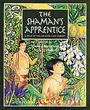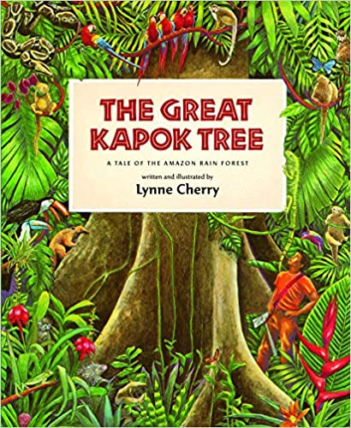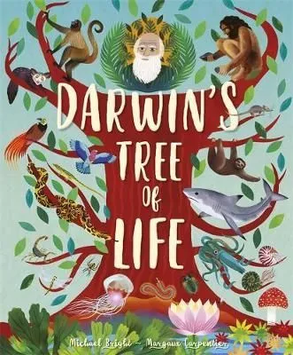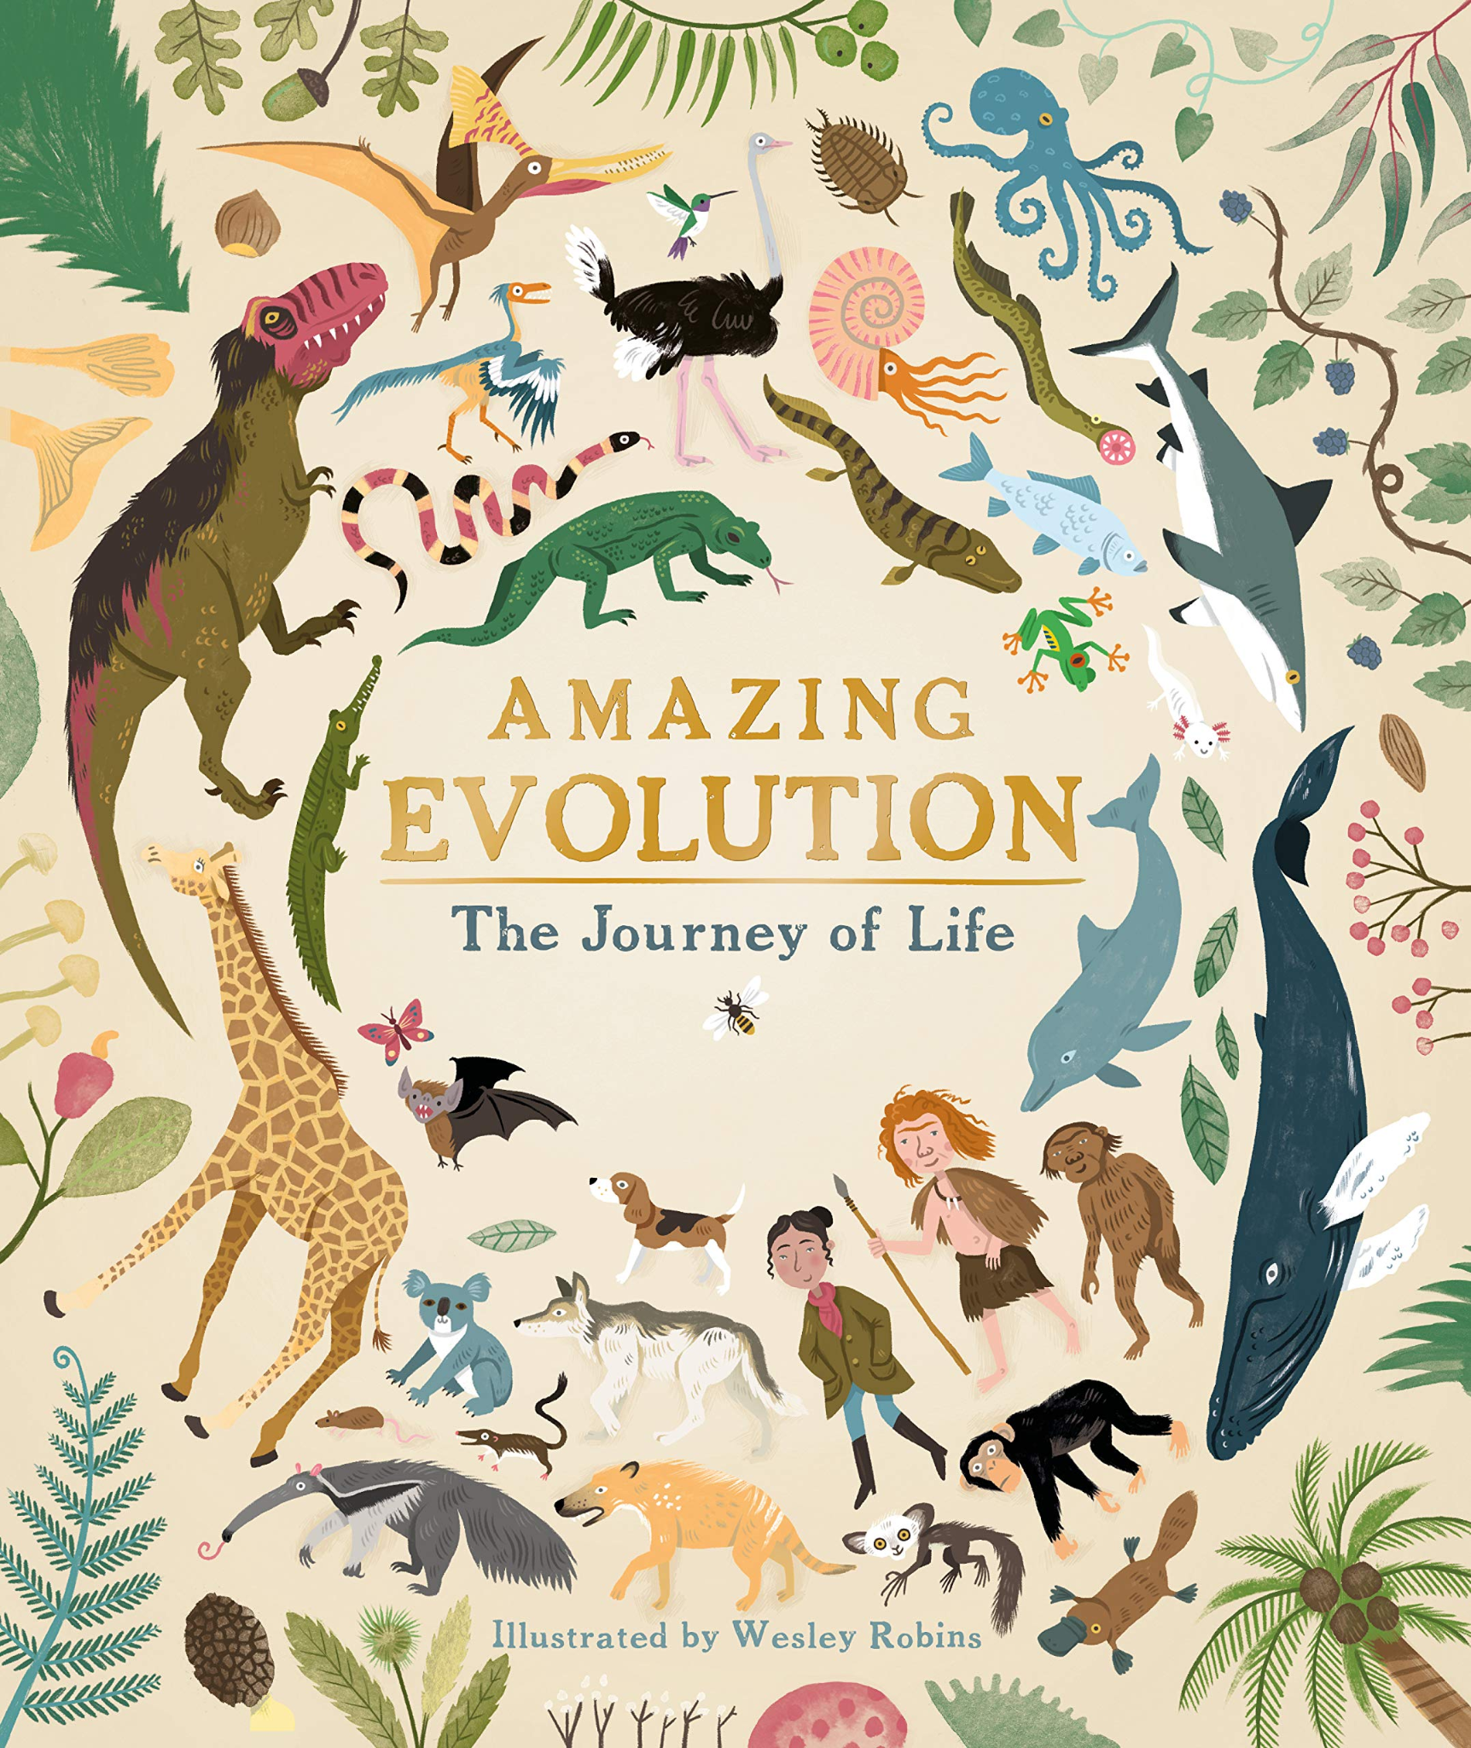
General Information
Reminders and Dates:

Water bottle - In school everyday and named.
Please make sure that all items of uniform have names in them and check that names have not washed out.

Dates:
- Monday 29th June - KS2 Sports Day at King’s Park
- Friday 10th July - Year 6 Leavers Disco - 5:30-7pm in the school hall

