Corpus Christi Catholic Primary School
Year 1 Curriculum Overview Summer 1 2026

This half term, our Curriculum Enquiry Question is:
What makes a good leader?

Our School Gospel Virtue is Compassion
RE |  | Catholic Character Education/RSHE |  | English
We are learning all about the Easter story in RE and reflecting on the thoughts, feelings and emotions of Mary and the Disciples.  We will think about what it means to be a witness and how the Disciples were a witness to Jesus in the Bible stories that we have learnt.  We will understand why Easter is a significant time in the Christian faith.  We will then move onto Pentecost and Mission where we will learn more about the importance of the Holy Spirit. |  | CCE:  We will be learning about Compassion, what compassion means and how we can show compassion to others as well as ourselves.  RSHE: This half term, we will be learning about who helps to keep us safe. We will learn the difference between a stranger and a trusted adult. We will also look at jobs that adults have that could help us in different situations e.g. if there is a fire a fireman could help. We will also learn what steps to follow if there is an emergency. |  | We will start the term by writing informational texts about animals. We will discuss what informational texts need - titles, subheadings, facts ect. And then write our own informational text about an animal of our choice.  We will then move ont to our class book - Paddington by Michael Bond - we will come up with our own version of Paddington's journey to Peru!
Maths |  | History/Geography |  | Arts and Culture
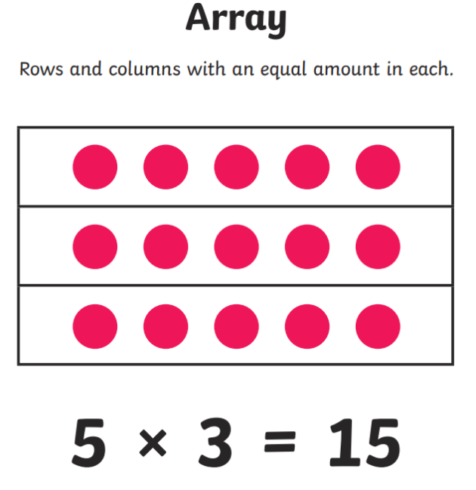  Multiplication and Division  We will be learning skip counting in 2’s, 5’s and 10’s. We will also be starting to use arrays to make equal groups.  Fractions  We will be recognising what a whole, half and quarter of quantity are.  Geometry- Position and Direction  We will describe turns and movement using language such as forward, backwards, above and below. |  | This half term in History we are doing a topic on Kings and Queens. We are having a special day on Friday 17th April dedicated to learning all about monarchs. We will learn about monarchs from all around the world, as well as King Charles III and his Coronation.  Children will discuss what Monarchs do and look at significant Monarchs throughout history.  We will also learn about other leaders and their roles. This includes our Prime Minister and learning about the work done in Parliament. |  | Art: In art, we will be exploring texture. We will be using the medium of clay and using different techniques and tools to create different textures. We will be making clay hedgehogs by the end of the term  Music: | Computing: In computing, we will be exploring how we can use computers to help us make lists and design things we are going to make. We will be building rockets and using a computer to help us in the listing and designing processes. We will then test how effective our rockets are by launching them on the playground.
Science |  | PE |  | Curriculum Texts
This half term, we will be learning about plants. We will learn the names of the different parts of a plant and also begin to categorise different types of plants.  We will also look at the different types of trees: deciduous and evergreen. We will learn what features the trees need in order to fit into the two different categories. |  | We will begin to practise the skills needed for sports day. These include balls skills, racing, jumping and throwing.  For our indoor sessions we will be doing dance; we will be focusing on the idea of growing and dancing with rhythm and pattern in mind. |  | 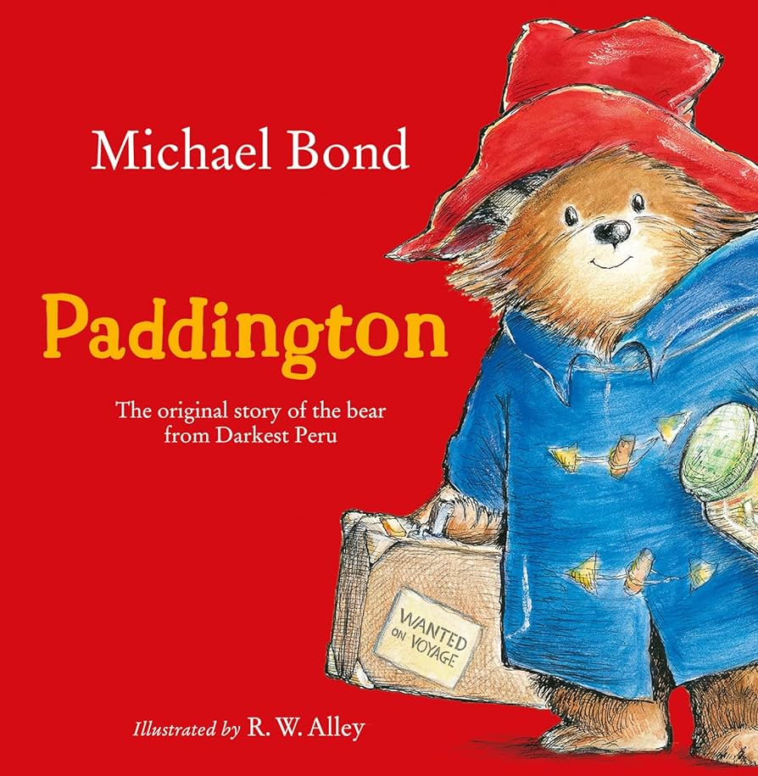
General Information
PE days - Monday (indoor) and Tuesday (outdoor)

Homework - sent out on Thursdays, due Tuesdays

Please make sure that with the weather warming up that your child has a named water bottle and hat in school. Please could you also ensure that every item of uniform is clearly labelled with your child’s name to prevent missing items.

