Corpus Christi Catholic Primary School
Year 2 Curriculum Overview Summer Term 1 2026
This half term, our Curriculum Enquiry Question is
“Can a small act make a big difference?”

Our School Gospel Virtue is: Compassion
Catholic Social Teaching: Common Good.
RE |  | Catholic Character Education/RSHE |  | English
In RE this term, we will be reflecting on the events of Holy Week, (particularly Easter Sunday) and looking at the difference between faith and doubt, using Doubting Thomas as an example.  We will then conclude Eastertide by beginning a new unit, Pentecost and Mission. We will look at the importance of the Holy Spirit when it descended upon the disciples and how it guides us today. |  | In CCE, we will be exploring our school Gospel Virtues of ‘Compassion’.  In RSHE, we will be learning about what helps us to grow and stay healthy. |  | Fiction- We will be reading Ron the Rat and The Great Fire of London and using this model text to write our own stories about the Great Fire of London! We will be especially focusing on the children’s vocabulary and descriptive skills.  Non-fiction- This half term we will be focusing on newspaper reports. We will be creating our own report on the Great Fire of London, detailing the events of the fire.  Poetry -  Children will be exploring the expressive poem “Homework, Oh Homework” by Jack Prelutsky. They will be using exaggeration to write their own poem in this style.
Maths |  | History |  | Arts, Languages and Computing
In maths we will continue to focus on mass, capacity and temperature.  We will then be learning about fractions before moving on to learning the time. |  | In History and Geography, we will be learning about the Great Fire of London! The children will learn about the history of London, become familiar with a timeline and be able to sequence the events of the Great Fire of London. We will be analysing artifacts and questioning how we know what happened in history. |  | Art/DT:  We will see how artists have documented London events in the past; including David Best's burning sculpture to reenact The Great Fire of London.  Music:  How singing helps us work together using Sea Shanties. | Computing:  Learning how data is collected, used and displayed and the scientific learning of the conditions needed for plants and humans to survive.
Science |  | PE |  | Curriculum Text
States of Matter  In Science, we will look at the three states of matter and objects that can be categorised into each state.  We will learn about the changes states make when moving to another state and the various shapes that the states can be put into.  We will experiment how chocolate changes from a solid to a liquid and a liquid into a gas. |  | In PE, the children will be using a variety of skills to practice for sports day. They will practice their running technique while ensuring they have the right skills for throwing and dribbling with a ball.  The children will also be learning about dance and creating patterns of movement. They will be listening to music linked with The Great Fire of London. |  | 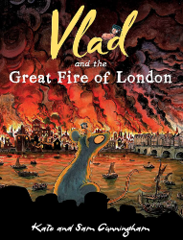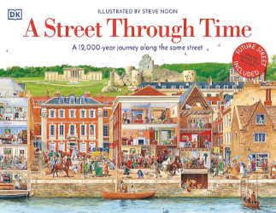
General Information
Reminders and Dates:
PE days: Tuesday and Wednesdays - Please send your child to school in their PE kit on these days.

Homework: Homework will be set on Thursdays and due on the following Tuesday.

Water bottle: In school everyday and named.
Please make sure that all items of uniform have names in them and check that names have not washed out.

Reading records are due every Friday. The children should have at least four comments in their record.
Children are expected to be responsible for handing in their own reading record, so that their book can be changed.

