Corpus Christi Catholic Primary School
Year 4 Curriculum Overview Summer Term 1 2026
This half term, our Curriculum Enquiry Question is
“How Does Failure Affect Us?”

Our School Gospel Virtue is: Compassion
Catholic Social Teaching: Solidarity
RE |  | Catholic Character Education/RSHE |  | English
In RE this half term, the children will be reflecting on the Easter period. They will look at both The Resurrection and The Ascension of Jesus, as well as specific scripture about The Road to Emmaus and how at times, we may forget or cease to recognise the presence of Jesus in our lives.  The children will conclude their learning on this unit by answering the Big Question ‘How do we know that Heaven is real?’ |  | In CCE, we will be exploring our school Gospel Virtues of ‘Compassion’.  In CST, we will explore the principle of ‘Solidarity’.  In RSHE, the children will be focusing on ‘Living in the wider world’ and how their choices make a difference to others and the environment. They will understand how people have a shared responsibility to help protect the world around them and explore how everyday choices can affect the environment. Children will also explore money and recognise what people choose to buy or spend money on can affect others or the environment. |  | Fiction - Dialogue  Through our class text ‘Varmints’, children are creating their own version of the text ensuring that dialogue has been used correctly.  Non-fiction - Persuasive Writing  Children will be creating a persuasive text linked with our learning on the Mayans. We will be attempting to sell state of the art Mayan weapons!  Poetry - Acrostic Poems  With a link to recent events, children will be creating acrostic poems about Space - linked to the Artemis II Moon Mission.
Maths |  | History |  | Arts, Languages and Computing
We will start out learning by reminding ourselves of what tenths look like in the form of fractions. Then, we will compare this to decimals forms of tenths and find similarities. We will do the same for hundredths.  We will find the correlation between dividing by 10 and 100 and the effect this has on one and two digit numbers. We will use place value charts to support this.  We will also look at time. We will learn to read an analogue and digital clock, read in the 12 and 24 hour format and solve problems involving adding and subtracting amounts of time.  Finally, we will learn about money. Pounds and pence, notes and coins, adding and subtracting amounts of money and comparing amounts.  In times tables, we will be consolidating all times tables in readiness for the MTC in June. |  | This half term, the children will be exploring the fascinating world of the Mayan civilisation. They will begin by identifying the modern countries once encompassed by the Mayan empire and examining the key geographical features of this region.  The class will then compare the structure of our own society with that of the ancient Maya, considering similarities and differences in how communities were organised. They will also investigate important cultural elements, including Mayan food, writing systems, the calendar, religious beliefs, and the practice of human sacrifice.  In addition, the children will learn about the work of an archaeologist and discover how artefacts help us piece together the lives of people from past civilisations. |  | Art/DT: Embroidery:  Learning new stitches and developing skills in sewing.  Music: Ukulele:  The children will continue learning the Ukulele. They will build skills playing in an ensemble, incorporating Ukuleles and other classroom instruments. | Spanish: La Ropa:  The children will be learning the names of clothing and the vocabulary needed to describe them.  Computing: Algorithms  Children will become familiar with the following elements of algorithms; decomposition, abstractions, looping codes, variables, conditional statements and debugging.
Science |  | PE |  | Curriculum Text
This half term in Science, the children will be exploring the states of matter: solids, liquids and gases. They will investigate the key properties of each state and learn how to classify materials based on these characteristics.  The children will also study reversible and irreversible changes, discovering which processes can be undone—such as water freezing into ice and melting back again—and which changes are permanent, like a raw egg turning into a cooked one.  Building on their Geography learning from the last half term, the class will examine how heating and cooling can cause materials to change state through evaporation, condensation and other processes, linking this knowledge back to the water cycle. |  | Indoor: Curling & Archery  For our indoor lessons, the children will experience curling and archery. They will understand the basics of each sport and then apply these skills to accumulate points.  4G has three remaining lessons left for swimming.  Then, 4D will be swimming this half term. Please check for communication regarding specific dates.  Outdoor: Sports Day Practice:  For their outdoor PE lesson, we will introduce the children to the activities they will compete in during sports day. This will include running, throwing and jumping events. |  | 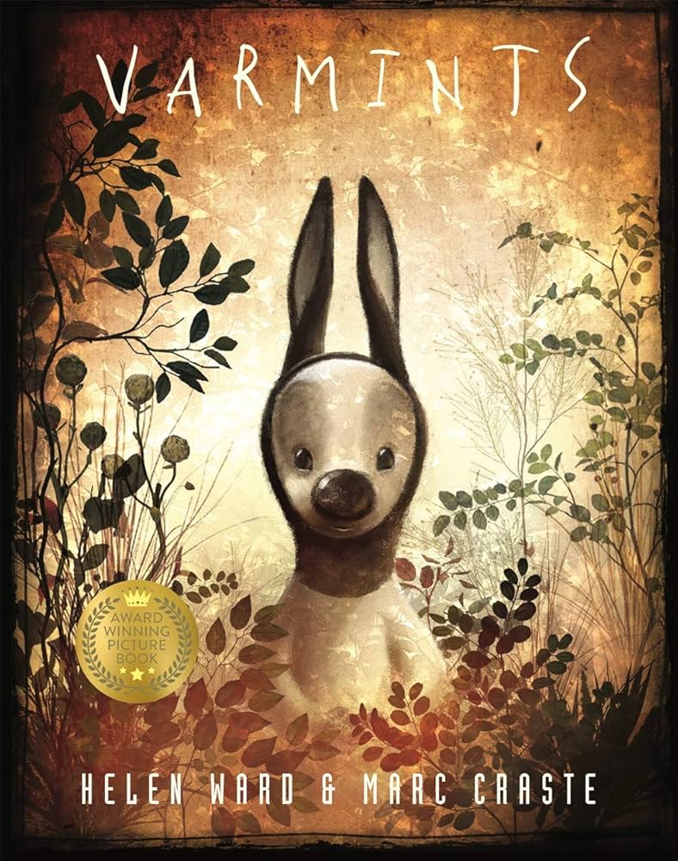  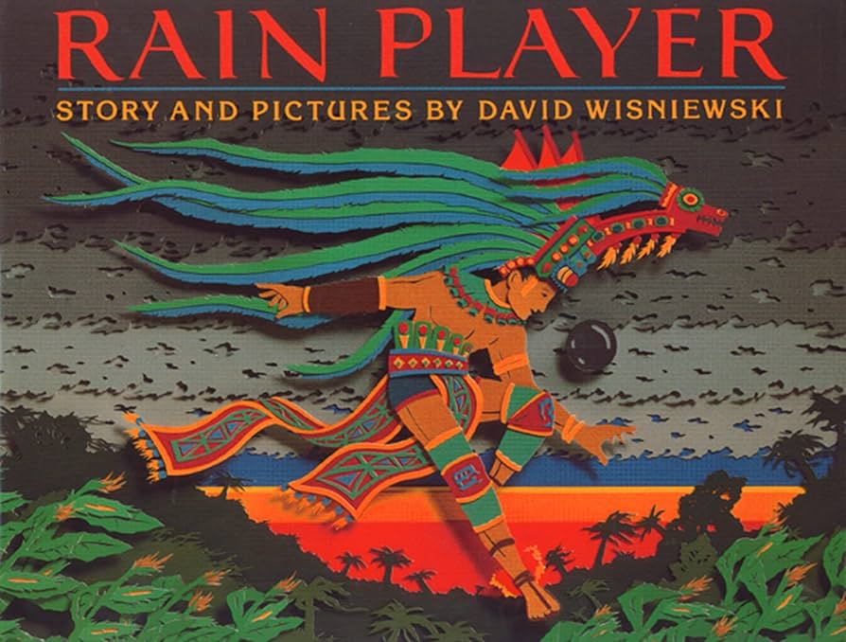
General Information
Reminders and Dates:
PE days: Tuesday and Fridays - Please send your child to school in their PE kit on these days.
Homework: Instructions will be posted on Google Classroom on a Thursday and the homework should be completed in their book. It is then due on Tuesdays.
Times Table Rockstars should also be used daily to support the learning of times tables.

Reading records are due every Tuesday. The children must have at least four comments in their record.

Water bottle - In school everyday and named.
Please make sure that all items of uniform have names in them and check that names have not washed out.

Dates:
- 4D swimming this half term - please check communication for specific dates
- Winchester Science Centre Trip - Friday 8th May
- Friday 22nd May - Last day of half term
- School reopens: Monday 1st June

