Corpus Christi Catholic Primary School
Year 5 Curriculum Overview Summer Term 1 2026

This half term, our Curriculum Enquiry Question is “What responsibility do we have to protect our environment?”

Our School Gospel Virtue is Compassion.
RE |  | Catholic Character Education/RSHE |  | English
We will be completing the unit of learning on Easter, focusing on the Easter Vigil and the Triduum.  We will connect the events of Holy Week, Easter and the liturgical life of the Church. By studying the Easter Vigil, pupils will develop a detailed understanding of the symbolism of Easter, as well as the beliefs that lie behind it. The story of Lazarus will help us to explore reactions to and the effects of the resurrection. The symbolism of the resurrection is also explored.  After this, we will be learning about the events of Pentecost and the impact on the disciples. |  | CCE: We are learning about the fragility of the environment and the need for us to safeguard it for future generations to enjoy.  We will also reflect on how we can show compassion to others, both in school and the wider world.  RSHE: We are learning about the difference between skills and qualities, and what ones we would like to have now and in the future. We will be thinking about different careers and different paths we can take to get certain careers to open our minds up for the future! |  | We will be starting with a non-fiction focus on explanation texts. We are linking this with our recent Science and History topics.  Then we will be moving onto script-writing for our fiction focus. We will perform playscripts as well as writing our own, so it is our chance to be actors, directors and screen-writers! We will use some computing sessions to combine our learning as we will type up our playscripts.  We then recap our previous learning on Haiku poems and have a go at writing our own, linking to the local wildlife we will be learning about in Geography.
Maths |  | Geography |  | Arts and Culture
We will start this half-term by learning about shape. Through this topic we will be estimating angles and also calculating angles around a point and on a straight line.  We will then go on to focus on position and direction. We will read and plot coordinates, and identify lines of symmetry.  We will end this half-term by beginning to focus on decimals. We will be subtracting decimals across 1 and with a different number of decimal places. |  | Geography: South Coast  We are learning about the south west region of the UK. We will build on Year 4 work on rivers and learn about rivers in Dorset and around Christchurch. We will also learn to recognise coastal features and understand how our coastline has been formed over millions of years.  We will study marine biomes around east Dorset and learn how human development affects these biomes.  We will discuss renewable energy and fossil fuels in Dorset and explore the differing opinions about the development of energy sources locally. |  | Art  We will be continuing to design and create our own stained glass windows.  5B will then be drawing and painting medieval inspired illuminated letters.  5C will be completing a design and technology unit, where they will be understanding CAMS mechanisms. | Spanish  ‘La Casa’  We will talk and write about homes, houses, flats and rooms.  We will be building longer sentences by combining fronted adverbial phrases (En mi casa) and conjunctions (y).
Science |  | PE |  | Curriculum Texts
Our Science unit is Living Things. We will be learning about plants and habitats.In particular, we will look at how different plants reproduce. We will also look at how local insects, birds and mammals reproduce in Dorset habitats, linking to our work in Geography. |  | We will be doing a combination of indoor and outdoor athletics this half term in preparation for Sports Day later in the Summer. |  | 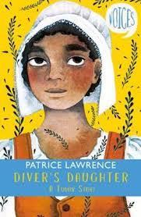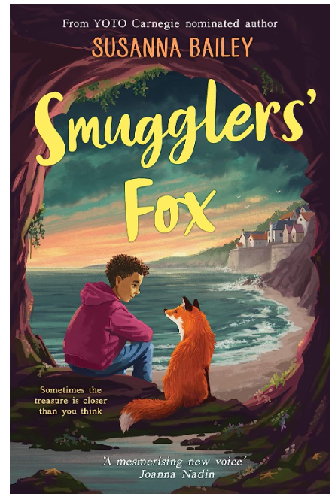
General Information
PE days have changed for this term.
5C: Tuesday, Thursday or Friday.
5B: Tuesday and Thursday.

Homework - Set every Thursday and due back every Tuesday, uploaded onto Google Classroom.
Reading records are due every Wednesday with a minimum of four comments per week. These are checked every Wednesday so please see any feedback written in reading records.

