**DIOCESE OF PORTSMOUTH**

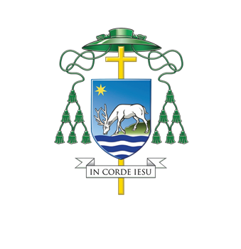

**Joanna Hooper**

has been appointed to serve as foundation governor of

Corpus Christi Catholic Primary School, Bournemouth

which is under the trusteeship of the Diocese of Portsmouth

in accordance with canon 803

to serve from 7th July 2020 until 6th July 2024

and as a member of the governing body

to conduct the school under my authority as Bishop

and in accordance with

the norms of canon law and the Education Acts



Rt Rev Philip Egan

The Bishop of Portsmouth

19th June 2020